 | Morning Meeting (8:10-8:30) | Math  (8:30-9:00) | ELA  (9:45-10:15) | Science/Social Studies  (10:15-10:30)
Monday | 8:10-8:30 - Live Teams Meeting | 8:30-8:50 - Live Teams Meeting  8:50-9:00 - Independent Work Time: “Counting to 15 Seesaw” Assignment  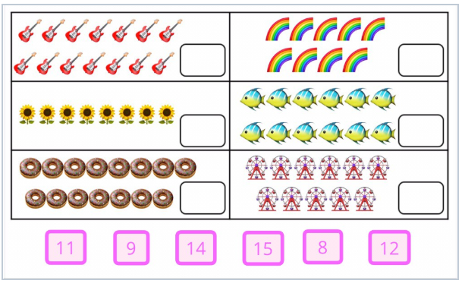 | 9:45-10:05 – Live Teams Meeting  10:05-10:15 – Independent Work Time: “Learning How to Use Seesaw” activity on Seesaw.  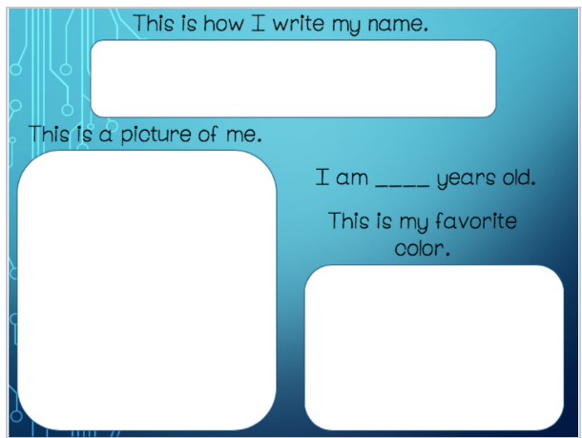 | 10:15-10:30 – Live Teams Meeting
Tuesday | 8:10-8:30 - Live Teams Meeting | 8:30-8:50 - Live Teams Meeting  8:50-9:00 - Independent Work Time: “How Many Letters in Your Name” activity on Seesaw.  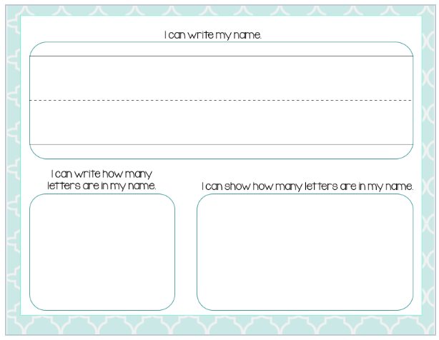 | 9:45-10:05 – Live Teams Meeting  10:05-10:15 – Independent Work Time: “First Day Jitters” activity on Seesaw.  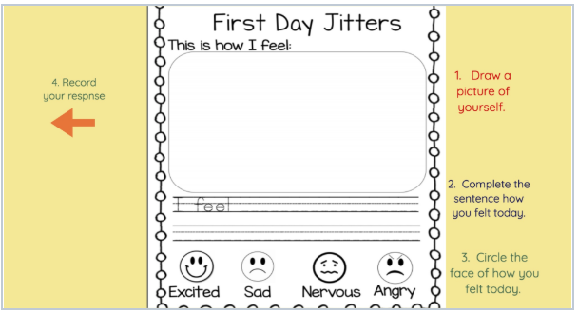 | 10:15-10:30 – Live Teams Meeting
Wednesday | 8:10-8:30 - Live Teams Meeting | 8:30-8:50 - Live Teams Meeting  8:50-9:00 - Independent Work Time: “Counting Practice” activity on Seesaw.  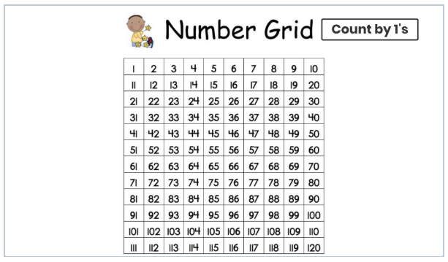 | 9:45-10:05 – Live Teams Meeting  10:05-10:15 – Independent Work Time: “All About Me” activity on Seesaw.  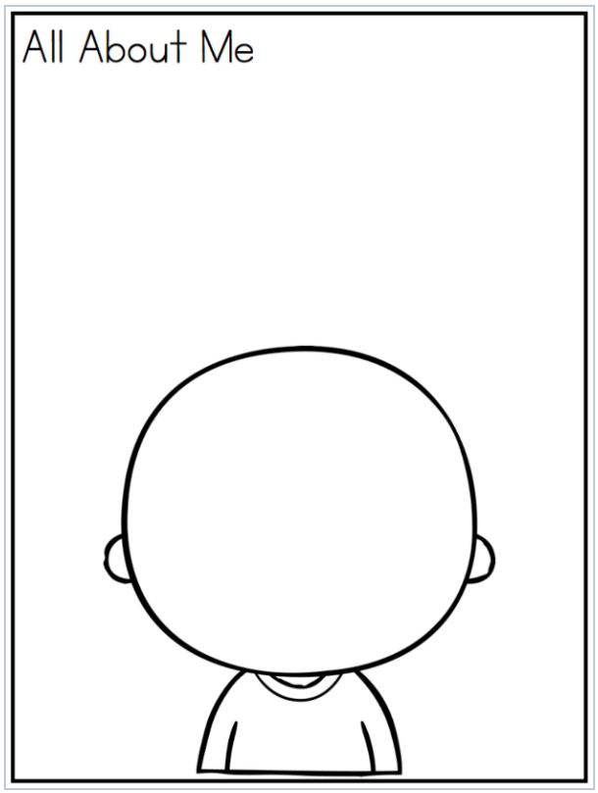 | 10:15-10:30 – Live Teams Meeting
Thursday | 8:10-8:30 - Live Teams Meeting | 8:30-8:50 - Live Teams Meeting  8:50-9:00 - Independent Work Time: “Find the Missing Numbers” activity on Seesaw.  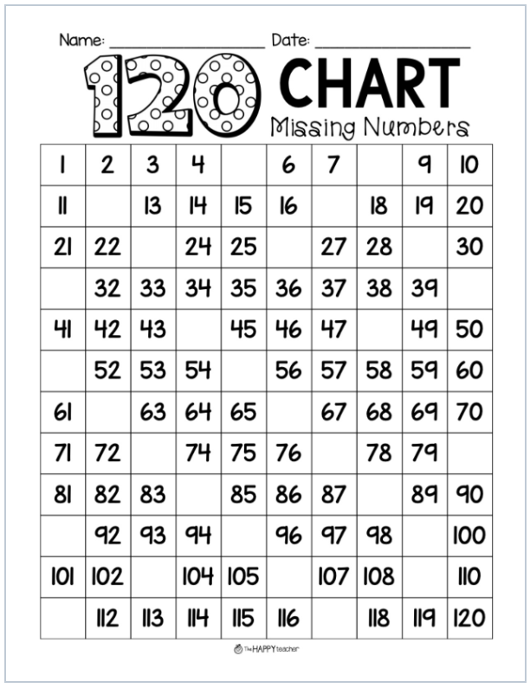 | 9:45-10:05 – Live Teams Meeting  10:05-10:15 – Independent Work Time: Write 1-3 sentences about your summer and draw a picture to go along with their writing in your composition notebook.  Take a picture and post it on Seesaw! | 10:15-10:30 – Live Teams Meeting
Friday | 8:10-8:30 - Live Teams Meeting | 8:30-8:50 - Live Teams Meeting  8:50-9:00 - Independent Work Time: “Skip Count by 10s” activity on Seesaw.  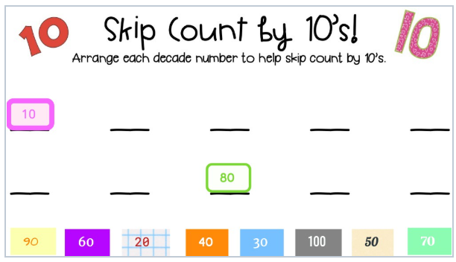 | 9:45-10:05 – Live Teams Meeting  10:05-10:15 – Independent Work Time: “Beginning, Middle, End” activity on Seesaw.  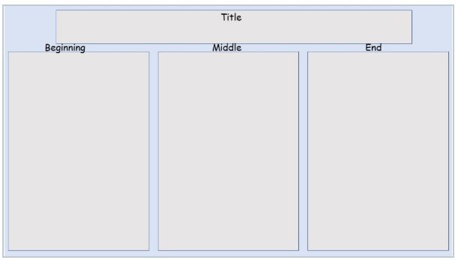 | 10:15-10:30 – Live Teams Meeting

Standards being covered this week:
Math
MGSE1.NBT.1 Count to 120, starting at any number less than 120. In this range, read and write numerals and represent a number of objects with a written numeral
ELA
ELAGSE1RL1: Ask and answer questions about key details in a text.
ELAGSE1W8: With guidance and support from adults, recall information from experiences or gather information from provided sources to answer a question.
Science
S1E1. Obtain, evaluate, and communicate weather data to identify weather patterns.
Social Studies
SS1G2 Identify and locate the student’s city, county, state, nation (country), and continent on a simple map or a globe.

