 | Morning Meeting  (8:10-8:30) | Math  (8:30-9:00) | Specials  (9:10-9:40) | ELA  (9:45-10:15) | Science/Social Studies – This will not be a live lesson.  (10:15-10:30) | Independent Reading & Math Work Time  (10:30-11:30 and 12:30-1:30)
Monday | 8:10-8:30 - Live Teams Meeting | 8:30-8:50 - Live Teams Meeting  8:50-9:00 - Independent Work Time: “Skip Counting in Fives” activity on Seesaw.  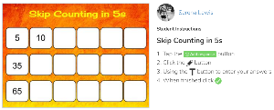 | P.E. | 9:45-10:05 – Live Teams Meeting  Phonics Poem -  10:05-10:15 – Independent Work Time: Character & Setting  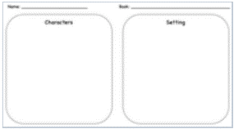 | 10:15-10:30  Seesaw Activity:  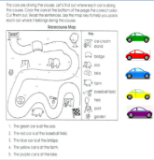 | Reading – Read a book for 15 minutes  Math – Choose a page in FCS packet  OPTIONAL: Students can choose to complete any of the items on the math or reading bingo board
Tuesday | 8:10-8:30 - Live Teams Meeting | 8:30-8:50 - Live Teams Meeting  8:50-9:00 - Independent Work Time: “Skip Count by 2s” activity on Seesaw.  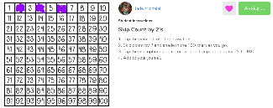 | P.E. | 9:45-10:05 – Live Teams Meeting  10:05-10:15 – Independent Work Time: “Chrysanthemum Character Traits”  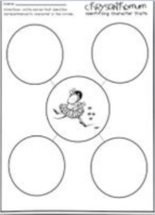 | 10:15-10:30 –  Seesaw Activity: complete the "Weather Words” activity on Seesaw.  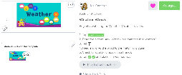 | Reading –Read a book for 15 minutes and log what they’ve read on their Reading Log in Seesaw  Math – Choose a page in FCS packet  OPTIONAL: Students can choose to complete any of the items on the math or reading bingo board
Wednesday | 8:10-8:30 - Live Teams Meeting | 8:30-8:50 - Live Teams Meeting  8:50-9:00 - Independent Work Time: “Counting on the Number Line” activity on Seesaw.  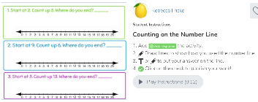 | Art | 9:45-10:05 – Live Teams Meeting  10:05-10:15 – Independent Work Time: Write 3 sentences about what you love.  Seesaw Activity: | 10:15-10:30  Seesaw Activity:  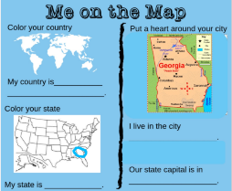 | Reading – Read a book for 15 minutes  Math – Choose a math page in FCS packet  OPTIONAL: Students can choose to complete any of the items on the math or reading bingo board
Thursday | 8:10-8:30 - Live Teams Meeting | 8:30-8:50 - Live Teams Meeting  8:50-9:00 - Independent Work Time: “Missing Number activity on Seesaw.  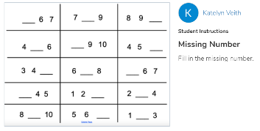 | Music | 9:45-10:05 – Live Teams Meeting  10:05-10:15 – Independent  Work Time:  Seesaw Activity:  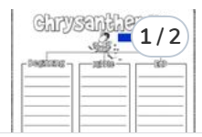 | 10:15-10:30 – Science  Seesaw:  Complete the “What’s the Weather” activity on Seesaw.  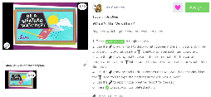 | Reading –Read a book for 15 minutes and log the reading time in the Reading Log on Seesaw.  Math – Choose a page in FCS packet  OPTIONAL: Students can choose to complete any of the items on the math or reading bingo board
Friday | 8:10-8:30 - Live Teams Meeting | 8:30-8:50 - Live Teams Meeting  8:50-9:00 - Independent Work Time:  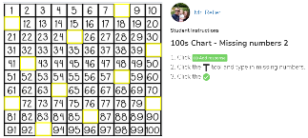 | Media Center | 9:45-10:05 – Live Teams Meeting  10:05-10:15 – Independent Work Time: Writing Seesaw Activity  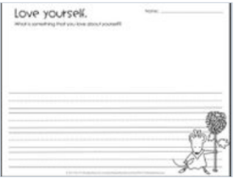 | 10:15-10:30  Go to Brainpopjr on Classlink and watch “Reading Maps” then do the  Seesaw Activity:  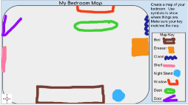 | Reading – Read a book for 15 minutes  Math – Choose a page in FCS Packet  OPTIONAL: Students can choose to complete any of the items on the math or reading bingo board

Standards being covered this week:
Math
MGSE1.NBT.1 Count to 120, starting at any number less than 120. In this range, read and write numerals and represent a number of objects with a written numeral
ELA
ELAGSE1RF3: Know and apply phonics and word analysis skills in decoding words.
ELAGSE1RL3: Describe characters, settings, and major events in a story, using key details.
ELASGSE1RL7: Use illustrations and details in a story to describe its characters, setting, or events
ELAGSE1W8: With guidance and support from adults, recall information from experiences or gather information from provided sources to answer a question.
Science
S1E1. Obtain, evaluate, and communicate weather data to identify weather patterns.
Social Studies
SS1G2 Identify and locate the student’s city, county, state, nation (country), and continent on a simple map or a globe.

